# BARD Query Examples

## Probe query

### Output

* “Beta-cell apoptosis”
* Query: ML#=214 (is a compound)
* Return:
  + Activity for ML214
  + All assays & result types that this compound used in
  + Result types: IC50, EC50, Solubility, DMPK, Inhibition
  + Assays: 1234, 72916, 1261, 32, 42, 10579

### Input

#### REG

Register Assay # 10579

* Components = CASPASE GLO
* DETECTION = ROLE
* CONCENTRATE = 1x
* Result Type = PE => EC50
* Cell = Hu Primary Beta cells
* Assay Management = LUMINESCENCE

#### DEP

Deposit Data

* Experiment 1
  + Source Date = 1/3/2011
  + Center = BROAD
  + GRANT# = NIH27-4271
* Experiment 2  
  Cloned from Experiment 1

Project into

* Name = “Beta Cell Apoptosis”
* Assay Role in this Project = “Counter Screen”

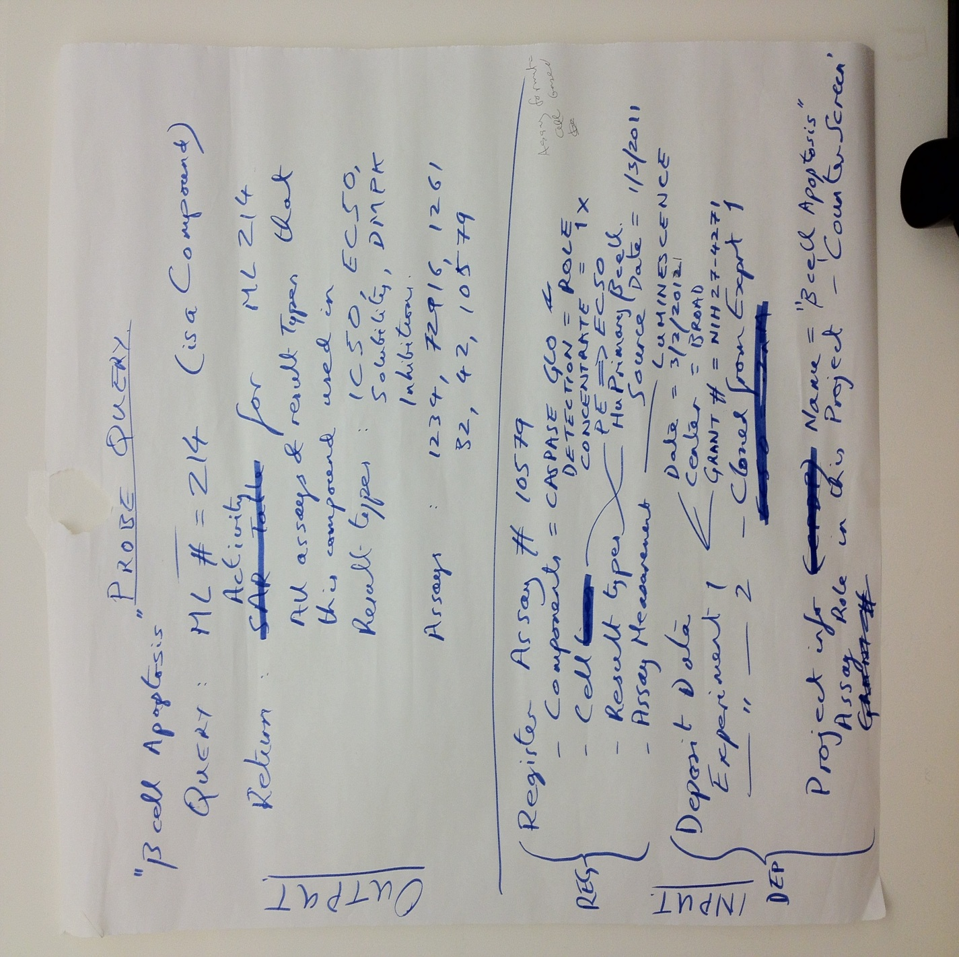

## Pathway Query

### Query

* Pathway = DNA Damage & Repair (🡪 GO 🡪 Target 🡪 BARD 🡪 Assay 🡪 Query Result)

### Query Result

* Assay ID#s = [73, 459, …] (and if appropriate, probe ML#s)

|  |  |
| --- | --- |
| Assay ID | Probe ML |
| 76 | - |
| 459 | ML258 |

* Assay 459 (all experiments (instances) below):

|  |  |  |  |  |  |
| --- | --- | --- | --- | --- | --- |
| SIDs | IC50 (uM) | PI | Hill Slope | S-zero | S-infinity |
| 8561 |  |  |  |  |  |
| 2439 |  |  |  |  |  |

* Data deposition = PubChem import
* Assay definition
  + Format = Biochemical (Nucleic Acid)
  + Component1
    - DNA Sequence x
    - Role = Target
    - Concentration = 100uM
  + Component2
    - DNA Probe 1
    - Role = Detection Probe
    - Concentration = 2nM
  + Measurement = Fluorescence @ 500 nM
* Data deposition
  + Grant ID = 29-86-534
  + Role = Confirmatory screen
  + Etc.

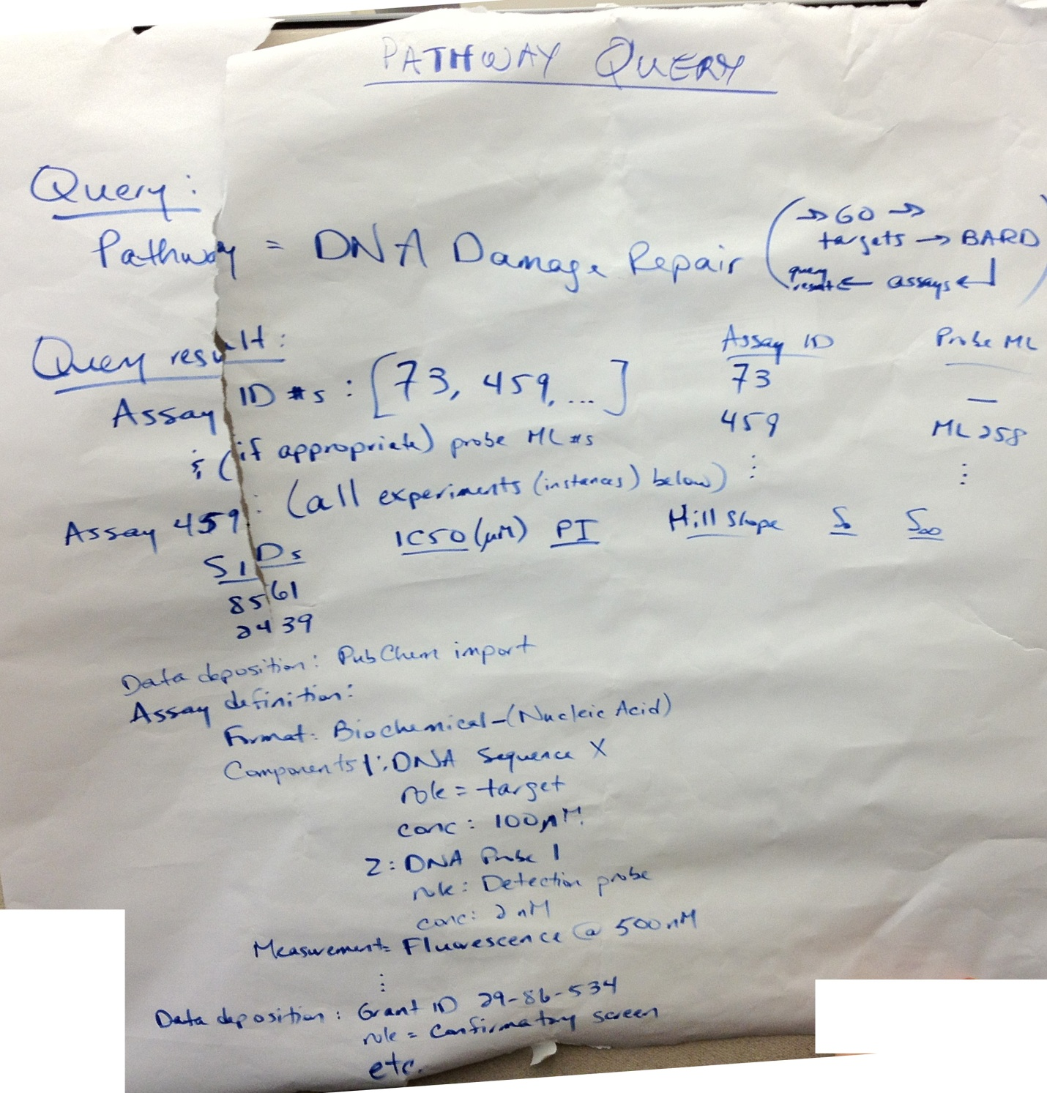

## Screening Campaign

### Query

* Grant # = NIH 21-27-39721A
* What I’m looking for = “Screening Campaign”
* Target = S1P3

## Returns:

* Rational = “S1P3 is a part of the _____ pathway for Chagas disease affecting 30 million people world-wide….”
* Number of probes generated = 5
* Assay Summary table:

|  |  |  |  |  |
| --- | --- | --- | --- | --- |
| Date | Type/Role | Result Type | Target | # of compounds |
| 1/21/2011 | Primary | PI single dose | S1P3 | 360,000 |
| 2/27/2011 | Confirmatory | P triplicate | S1P3 | 2,000 |
| 4/1/2011 | Counter Screen | PI triplicate | S1P1 | 2,000 |
| 5/15/2011 | Dose-response Confirmation | Doe-response | S1P3 | 1,200 |
| 7/7/2011 | Metabolism | Clearance | - | 10 |

Register assay 🡪 Screening Campaign

Assay format

* Biochemical – protein target

Assay Components

* S1P3
  + Target = role
  + Concentration = 100nM
* AAAA = peptide
  + Role = substrate
  + Concentration = 1uM
* Antibody = anti-AAAA
  + Role = detection
  + Concentration = 1.5nM
* Anti-antibody = Anti-anti-AAAA-fluorescein
  + Role = detection
  + Concentration = 1.5nM

Assay Measurement

* Fluorescence
  + Wavelength = 510nM
  + Reader = Envision

Assay Design

* Fast print = 384 wells

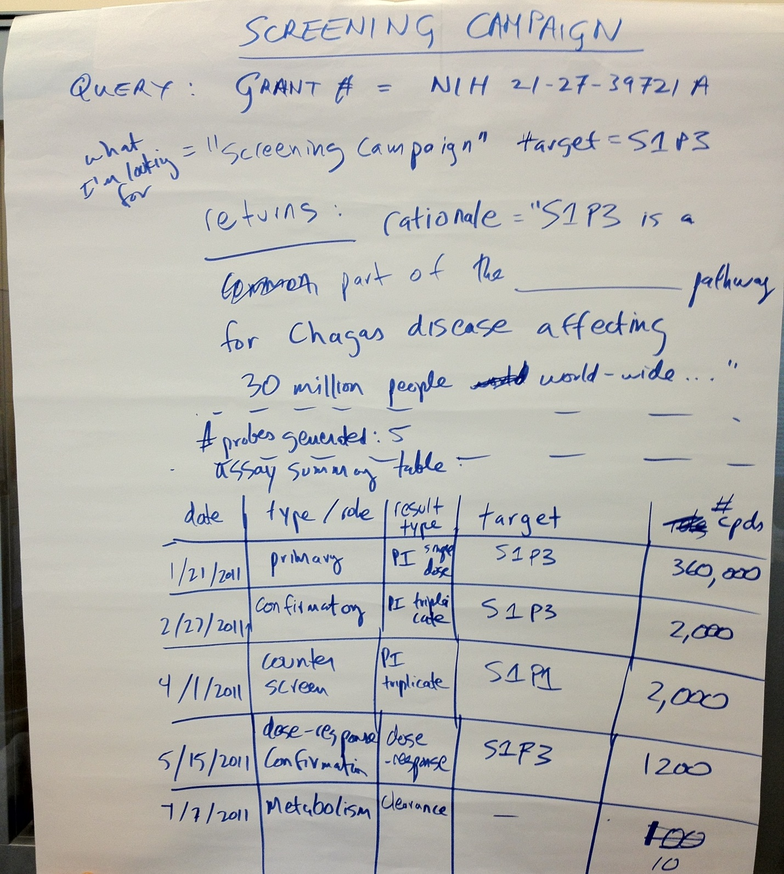

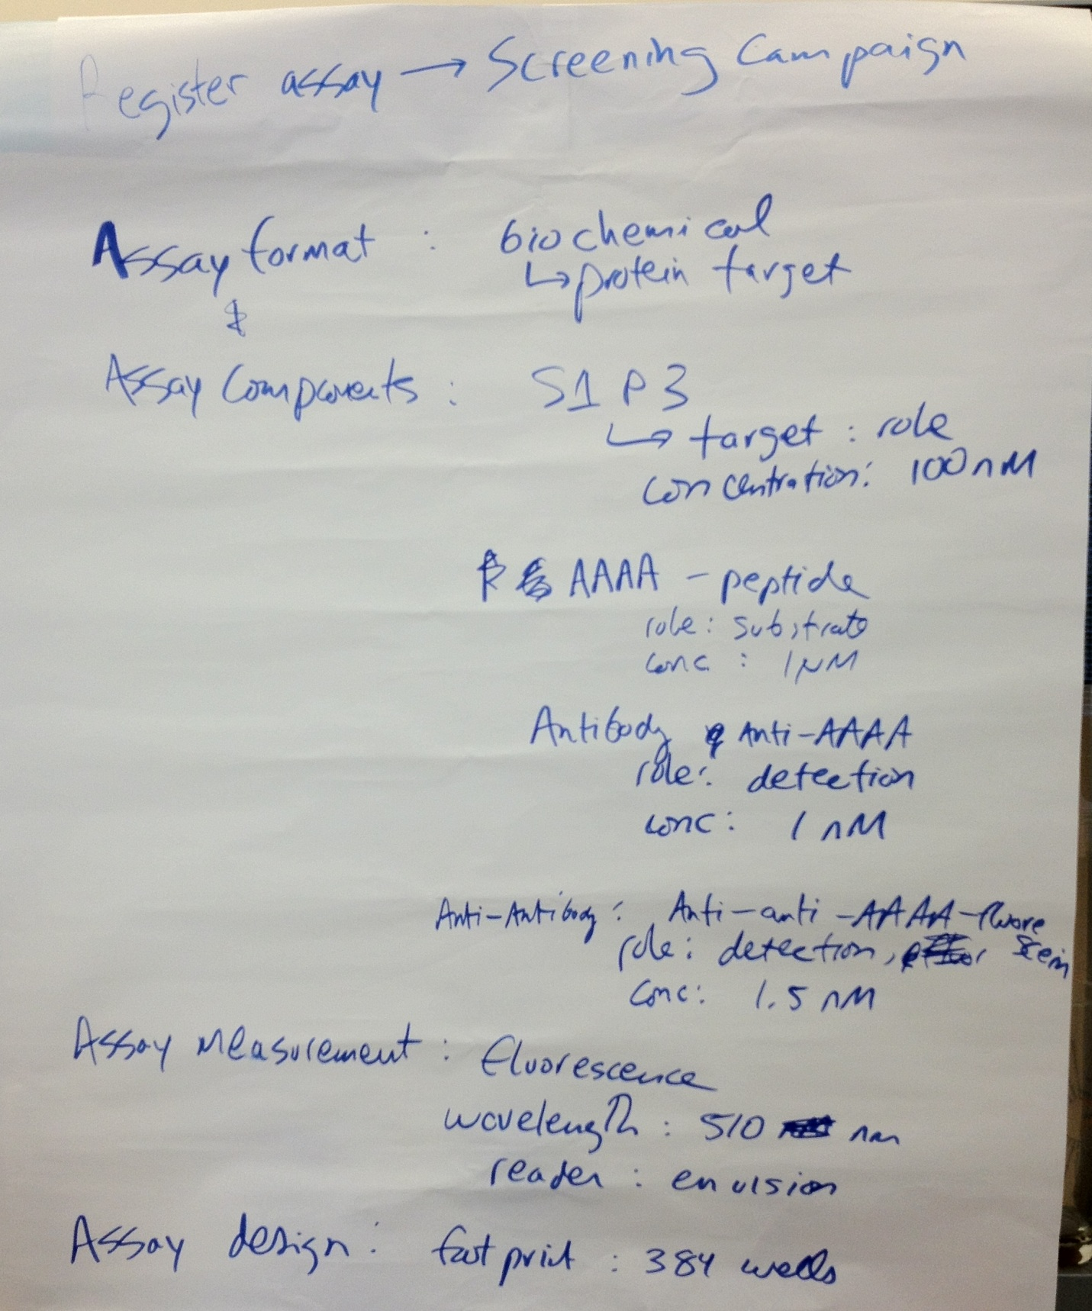

## Promiscuity Query

### Output

I want to know how many assays this compound hit in with respect to number of assays performed.

#### Query

* CID = 40503 (or a list)

#### Result

* Count of assays with 40503 in it
* Count of assays where result exceeded (?) the threshold for that assay  
  Do we store the “Activity Score”?

### Input

* Assay definition for: 3271, 4869 (IC50), 4870 (PI), 10504, …
* Expected Results + Context:
  + EC50
  + IC50
  + t1/2
  + PI
  + P.E
* Project info – Grant # = NC127-3216
* Experiment #32 uses assay 3271, EC50 has threshold < 1uM for hit
* Experiment #2491 uses assay 4870, PI has threshold > 60% for hit which were then screened in 4869
* Etc.

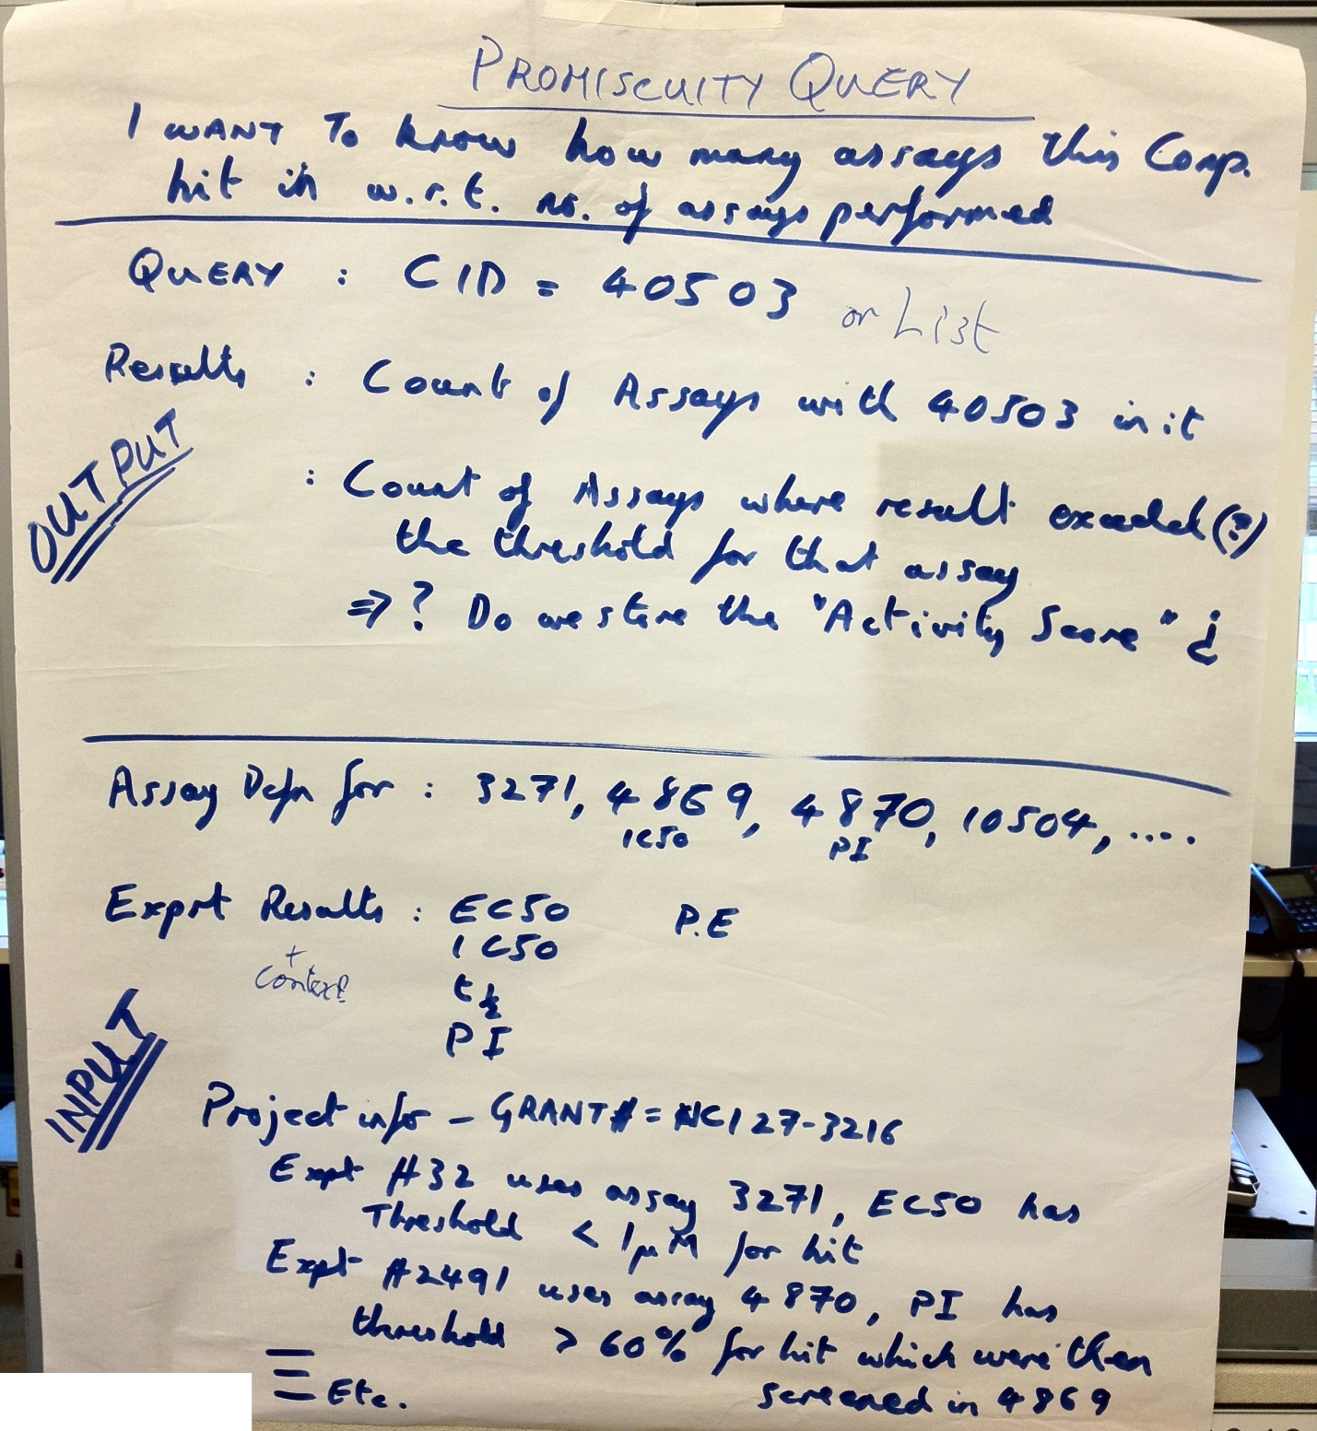

## Project Info

Define Assay 🡪 Input template 🡪 load into BARD

* Experiment Metadata
  + Experiment Name
  + Experiment Date
* Project Instance
  + Project #
  + Stage
  + Threshold
* Results:
  + IC50
  + PI
  + Concentration
  + Etc.

### Data Deposition & Project Capture

1. Project 1:
   1. Assay (experiment) – Threshold
   2. Add later by ‘dropping the experiment into a new project’
2. Project 2:
   1. Threshold
   2. Specify a new project

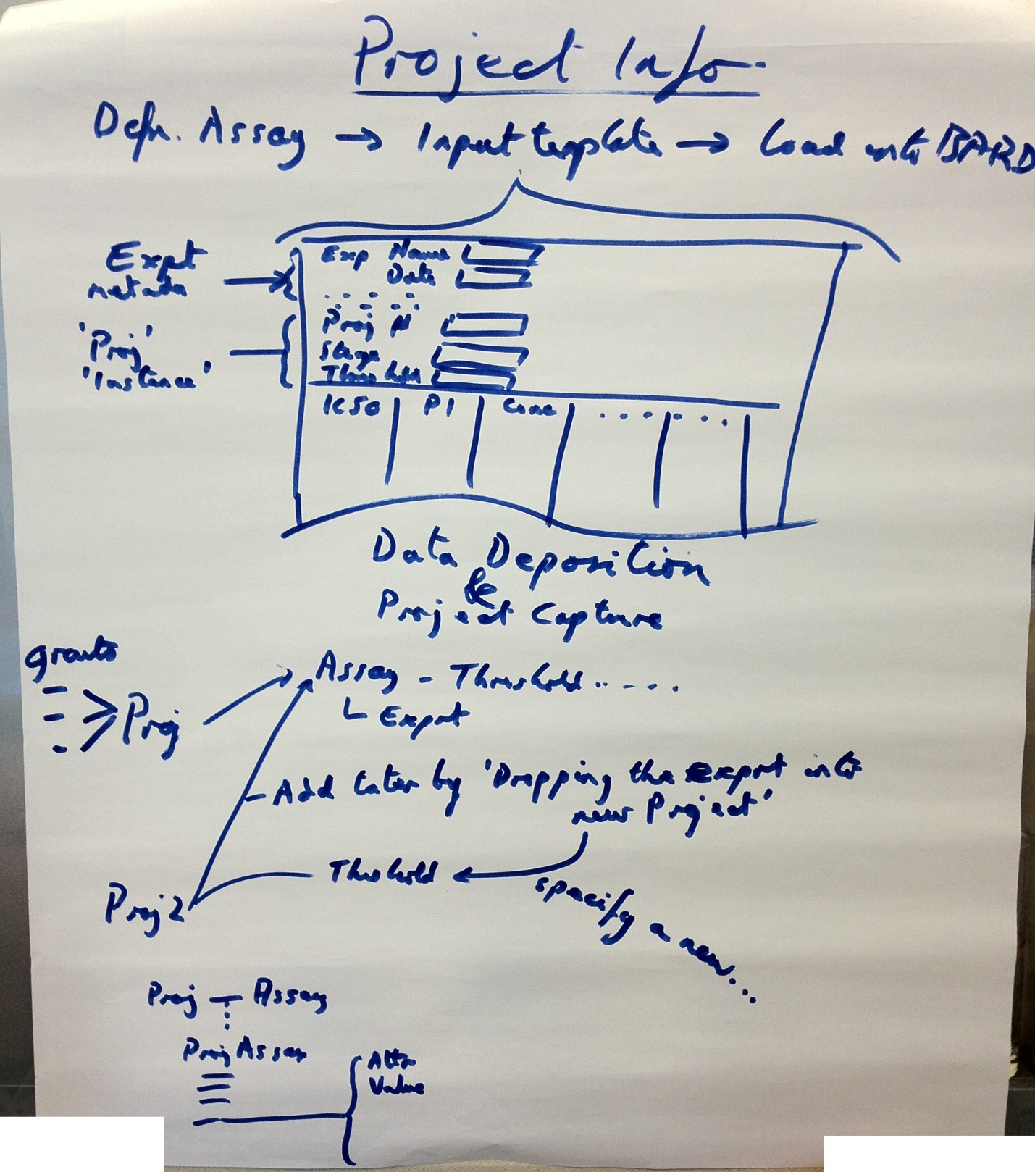

## Additional Pages

